H.T No
Regulations:
A18

Sreenidhi Institute of Science and Technology
(An Autonomous Institution)
Code No: 7AC07 Date: 31-Dec-2022 (FN)

B.Tech III-Year I- Semester (A18) Special Supplementary Examination - December-2022
CONTROL SYSTEMS (ECE)

Time: 3 Hours Max.Marks:70

Note: a) No additional answer sheets will be provided.
b) All sub-parts of a question must be answered at one place only, otherwise it will not be valued.
c) Missing data can be assumed suitably.

ANSWER ANY 5 OUT OF 8 QUESTIONS. EACH QUESTION CARRIES 14 MARKS.

Bloom's Cognitive Levels of Learning (BCLL)
Remember | L1 | Apply | L3 | Evaluate | L5
Understand | L2 | Analyze | L4 | Create | L6

 |  |  | BCLL | CO(s) | Marks
1. | a) | Determine the transfer function X₁(s)/F(s) for the mechanical system shown in below figure.  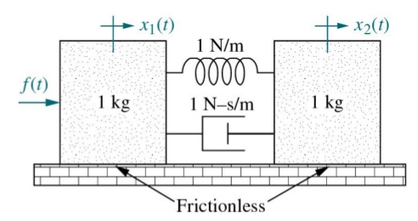 | L3 | CO1 | [7M]
 | b) | Determine the transfer function of the system represented by below signal flow graph.  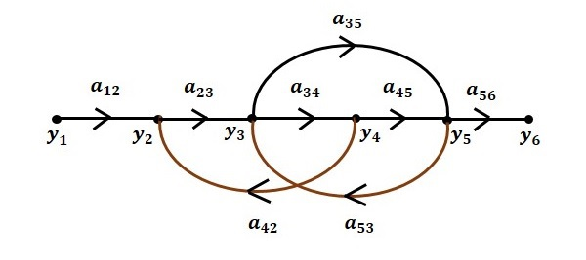 | L3 | CO1 | [7M]
2. | a) | The open loop transfer function of a control system with unity feedback is given by G(s) = . Determine steady state error of the system when the input is 10+5t+2t². | L2 | CO2 | [7M]
 | b) | Differentiate between P, PI and PID controllers. | L1 | CO2 | [7M]
3. | a) | Test for stability and determine the location of roots of the characteristic equation | L3 | CO3 | [7M]
 | b) | Sketch root locus for the system having transfer function    Also comment on the stability. | L3 | CO3 | [7M]
4. | a) | Elaborate on the different frequency domain specifications of a system, with a example. | L3 | CO4 | [7M]
 | b) | Sketch Bode plot of the following system  G(s)H(s) = | L6 | CO4 | [7M]
5. | a) | Sketch polar plot for the unity feedback system with open loop transfer function  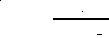 | L3 | CO5 | [7M]
 | b) | State and explain the Nyquist stability criterion | L2 | CO5 | [7M]
6. | a) | Explain with an example to derive a state model of any system. |  | CO6 | [7M]
 | b) | Given the system 𝑥̇(t ) = A x(t )+ B u(t ), Y(t) = C x(t) Where  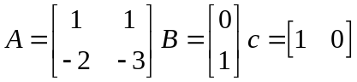  Determine the state controllability, output controllability and observability of the system | L3 | CO6 | [7M]
7. | a) | Explain working principle of Synchros. | L2 | CO1 | [5M]
 | b) | Explain the effect of proportional, derivative and integral controllers. | L2 | CO2 | [5M]
 | c) | Explain the concept of Routh stability, considering all the possible cases. | L2 | CO3 | [4M]
8. | a) | Explain the terms gain and phase margins with respect to frequency response analysis of control systems. | L1 | CO4 | [5M]
 | b) | Write short notes different compensation techniques. | L1 | CO5 | [5M]
 | c) | How do you develop state model from block diagram? List the steps. | L6 | CO6 | [4M]

-- 00 -- 00 –

